Assignment 4:

Move and Place a particular object from an image to a different image.

Before image:

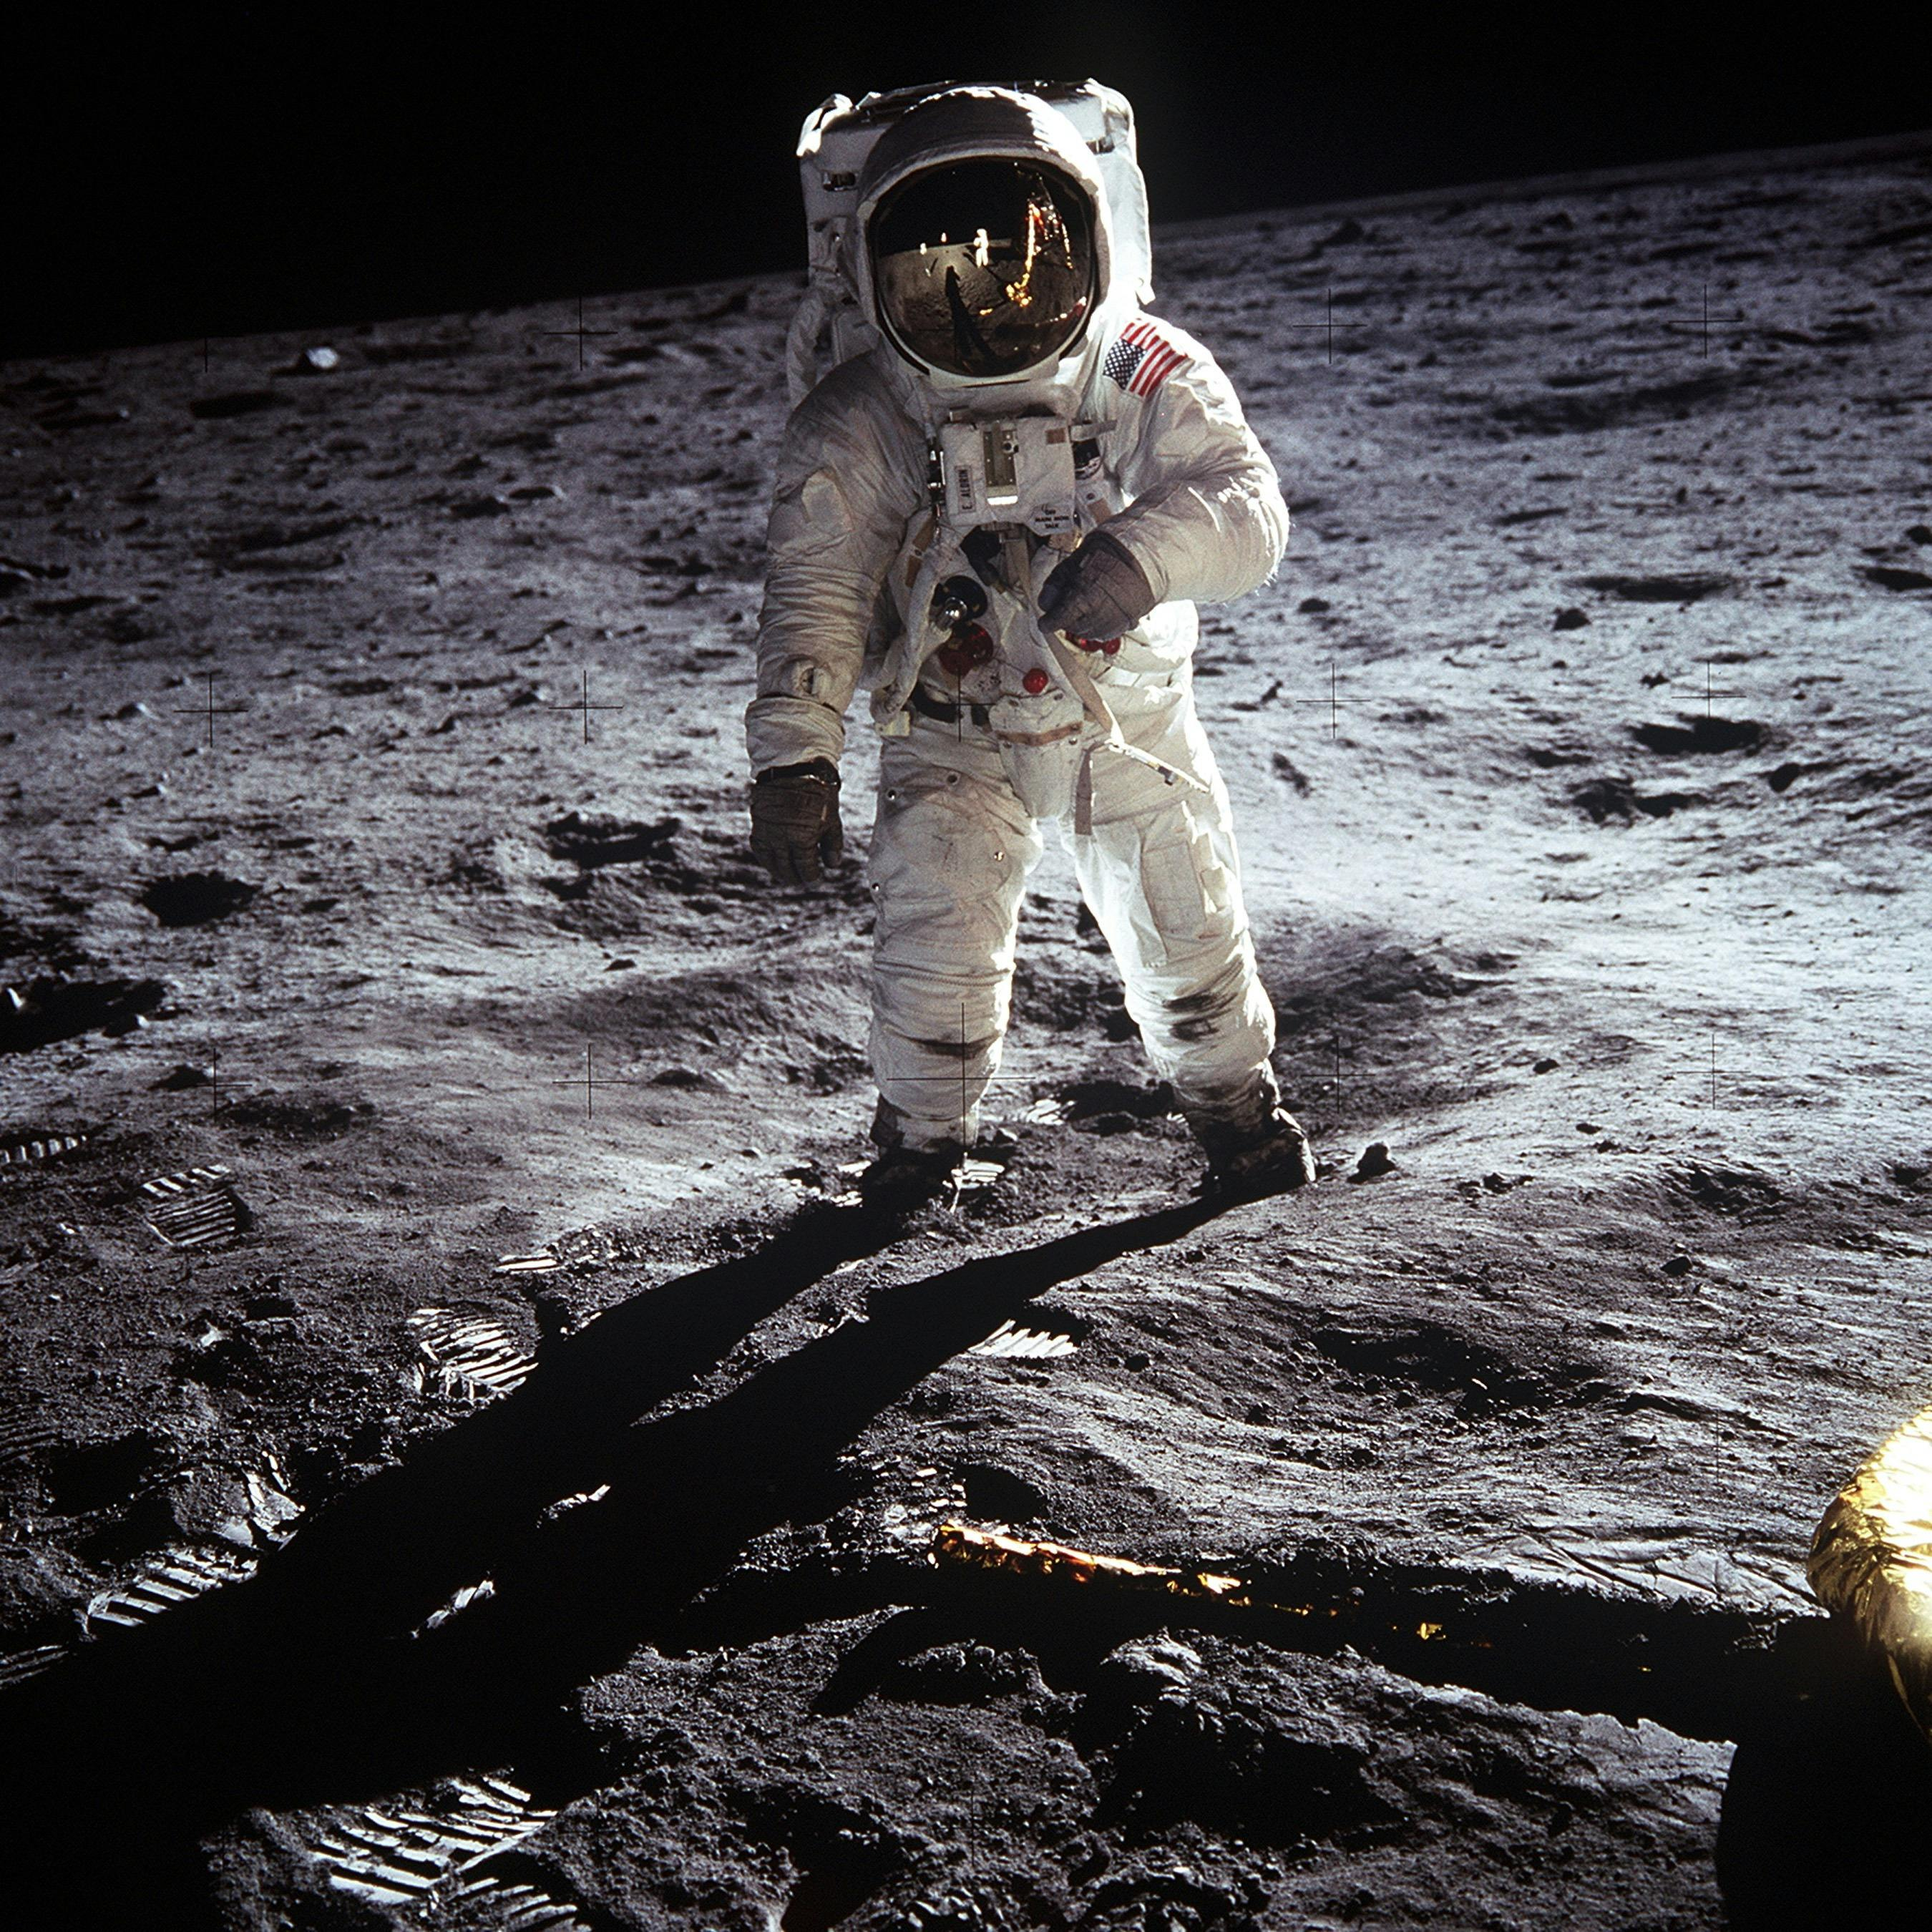

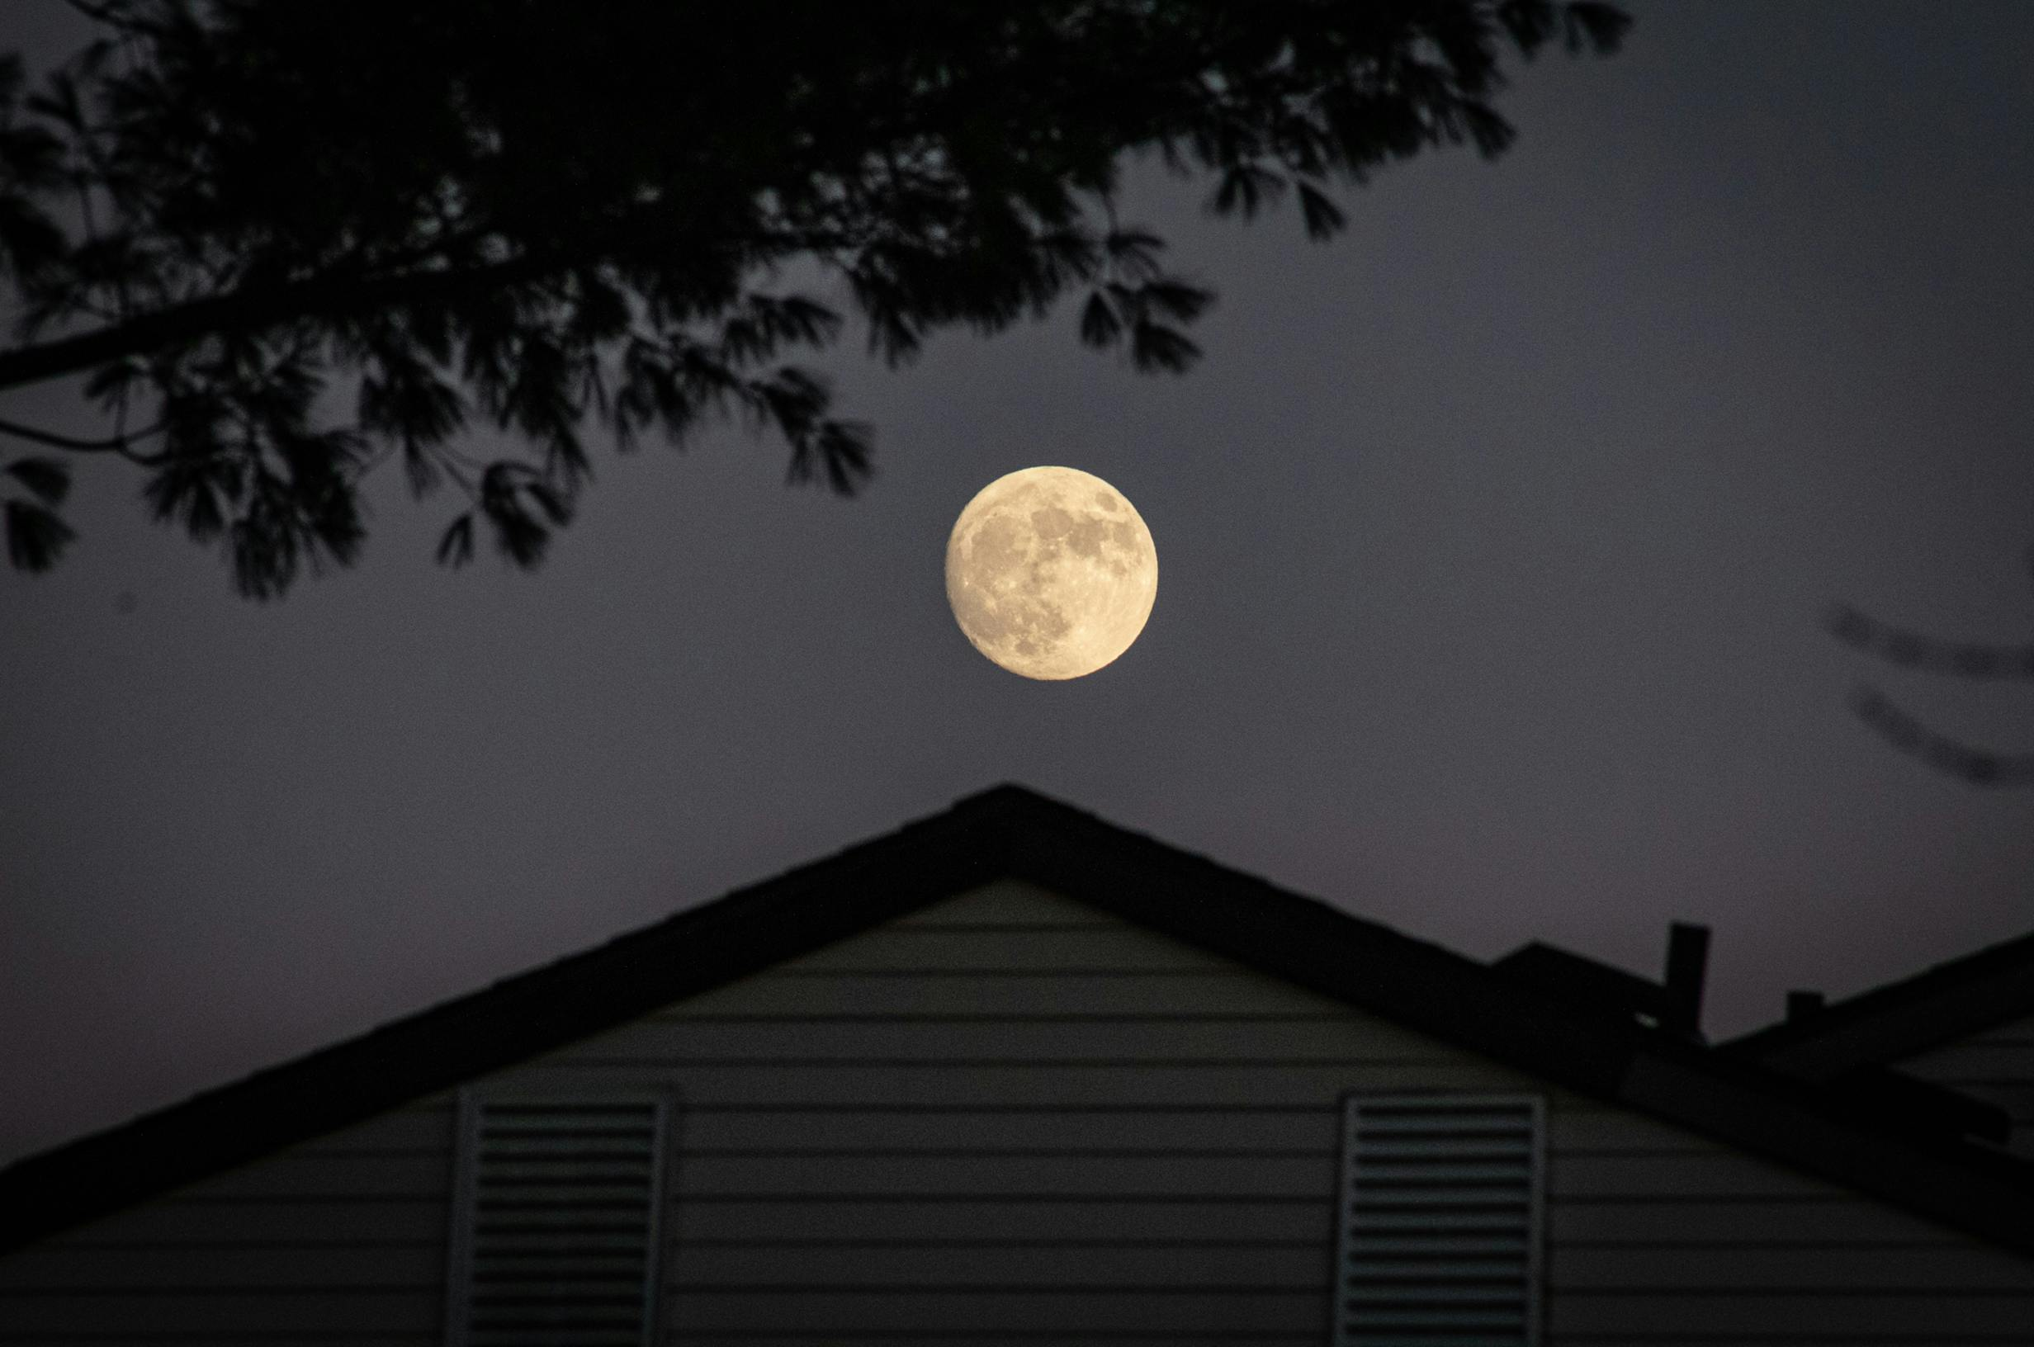

Steps:

* Open both the images.
* Select the object from source using “Quick Selection Tool”.
* Use “ctrl + j” to create a new layer containing the selected image only.
* Using move tool (left menu list) drag it on the target image tab and place it on the desired place in target image, it will become a new layer (say, “layer 1”) in the target image.
* Select layer 1 (i.e., dropped image) and select “Rectangular Marquee Tool” (left menu list).
* Right click on the image and select “Free Transform” and change its shape is needed.
* Save your master piece.

After image:

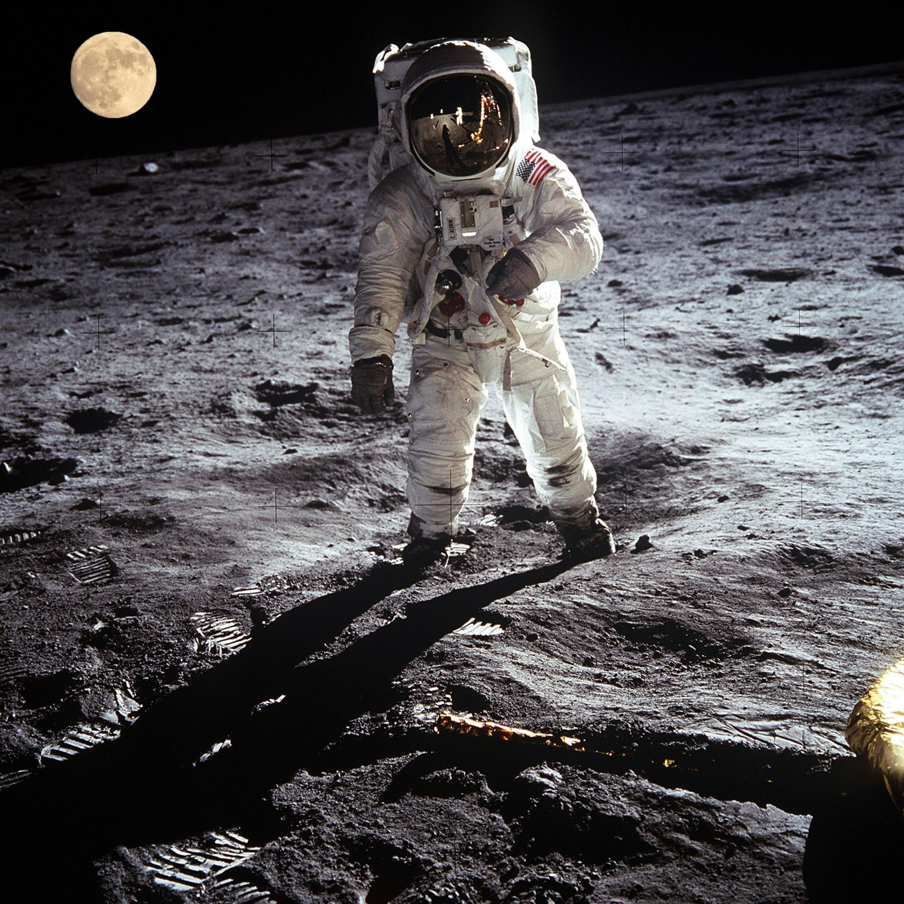

Assignment 5:

Create blur background of the image.

Before image



Steps

* Open an image.
* Select Quick Selection Tool (left menu list) and use it to select the fore ground.
* Use “Brush +”, “Brush -“ and “Brush size selector” opetions of Quick Selection Tool (top menu list) to respectively select, deselect portion of image and change brush size.
* After the image is selected, Right Click on the image and select “Select Inverse”, to select the back ground.
* Go to Filter -> Blur -> select Gaussian Blur.
* Adjust blur radius (intensity) and click OK.
* Right Click on the image and select “Deselect”.
* Save your master piece.

After image

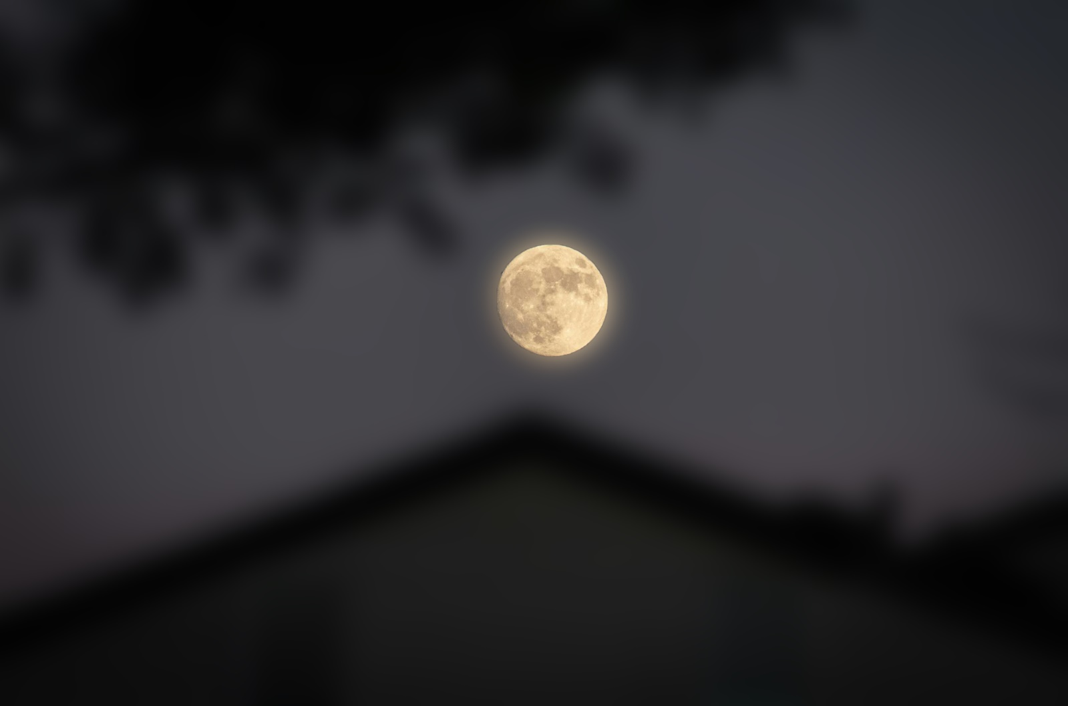

Assignment 6:

Change the colour of the particular portion of the image using hue saturation.

Before image



Steps

* Open an image.
* Select Quick Selection Tool (left menu list) and use it to select the fore ground.
* From “Create New Fill or Adjustment Layer” (bottom right, below list of layers) select Hue/Saturation Option.
* Adjust the intensities of the colors accordingly.
* Save your master piece.

After image

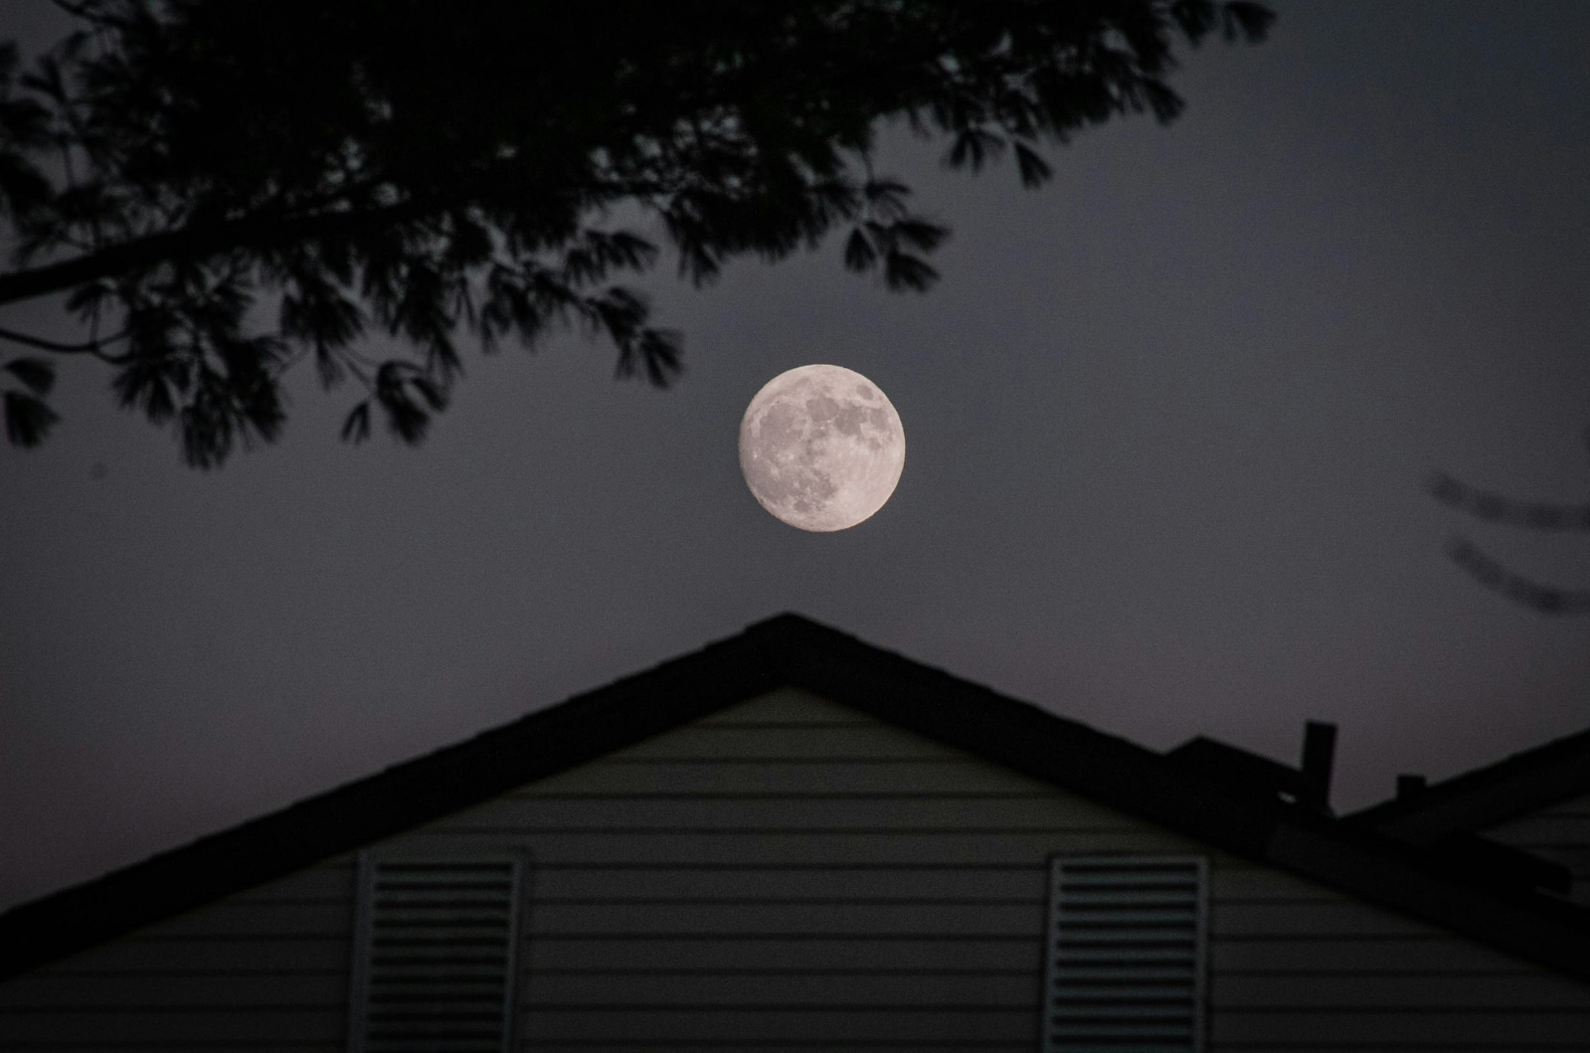

Assignment 7:

Remove unwanted objects from the image.

Before image



Steps

* Select object of the image to be removed using Spot Healing Brush (left menu list, looks like a band-aid).
* Save your master piece.

After image

